# Stage 1 Verification Report Submission Template

# Title

Verification Report: A critical reanalysis of Vahey et al. (2015) “A meta-analysis of criterion effects for the Implicit Relational Assessment Procedure (IRAP) in the clinical domain”

# Abstract

Vahey et al.’s (2015) meta-analysis of clinically-relevant studies using the Implicit Relational Assessment Procedure (IRAP) concluded that it has potential “as a tool for clinical assessment”. They reported power analyses which have since been frequently cited as a rationale for sample size determination. The current article assesses the computational reproducibility of Vahey et al.’s claims. On the whole, conclusions could not be reproduced and many apparent errors were detected, generally in favour of over-estimating the IRAP’s validity. A new meta-analysis and power analysis suggested that the IRAP has weak criterion validity for clinically-relevant variables and requires very large sample sizes.

# Keywords

implicit relational assessment procedure; implicit attitudes; meta-analysis; criterion validity; verification report

# Introduction

At minimum, the introduction should include a brief introduction to the topic, and a clear justification of the importance of the verification attempt.

Indirect measures of implicit attitudes have seen wide use in many areas of psychology research over the last twenty five years, including psychopathology research (e.g., Greenwald & Lai, 2020; Roefs et al., 2011). Unlike self-reports, implicit measures aim to infer individuals’ attitudes through reaction time biases, misattributions, and other forms of automatic behavior (De Houwer & Moors, 2010; although see Corneille & Hütter, 2020).

A meta-analysis of one implicit measure, the Implicit Relational Assessment Procedure (IRAP: Barnes-Holmes et al., 2010), concluded that it possesses good criterion validity and ”demonstrates the potential of the IRAP as a tool for clinical assessment” (Vahey et al., 2015). In Vahey et al. (2015), the authors (a) provided an estimate of the association between IRAP effects and clinically-relevant criterion variables, (b) reported that the IRAP compares favorably to other a more popular implicit measure, the Implicit Association Test (Greenwald et al., 1998), and (c) used their meta-analyzed estimate of effect size to conduct power analyses and make sample size recommendations for future research using the IRAP. In the following paragraphs I discuss three strong rationales to perform a verification of Vahey et al. (2015).

First, there is good a priori reason to believe that meta-analyses in general often contain non-replicable results. Lakens et al. (2017) recently demonstrated that the results of the majority of a random sample of meta-analyses published in psychology cannot be reproduced. Maassen et al. (2020) found that almost half of effect-sizes reported in meta-analyses of psychology research could not be reproduced from the original articles. This was attributed to due to a variety of issues such as errors in the extraction of effect sizes from original studies, insufficient details regarding data processing and transformation of effect sizes, insufficient details of the specific meta-analytic approach employed, or failures to adhere to meta-analysis reporting guidelines.

Second, Vahey et al.’s (2015) article has been well-cited and used to guide subsequent work. At time of writing, it has been cited 119 times with roughly 20% of articles citing it to justify sample size decisions (i.e., in lieu of a power analysis for that study). Studies employing the IRAP have typically involved small sample sizes of around 40 participants. This is frequently argued to be acceptable because it is in line with Vahey et al.’s (2015) sample size recommendation: “a sample size of at least N = 37 would be required in order to achieve a statistical power of .80 when testing a continuous first-order correlation between a clinically-focused IRAP effect and a given criterion variable” (p. 63). McEnteggart (2015) provided a particularly clear characterization of the importance of Vahey et al.’s (2015) results for practices in the broader IRAP literature: “the *N*s involved in [IRAP] studies … are often relatively small. ... Indeed, it could be argued that this impacts upon on the credibility of IRAP research. However, in a recent meta-analysis of IRAP studies, it was reported that even small *N* IRAP studies have sufficient statistical power.” (p. 166). Given that research continues to rely on the conclusions of Vahey et al.’s (2015) meta-analysis, it is therefore important that its results are computationally replicable and accurate.

Third, there is currently an incompatibility between the findings of different meta-analyses of the IRAP literature. On the one hand, three different three meta-analyses have all concluded that the IRAP’s reliability that is poor (Golijani-Moghaddam et al., 2013; Greenwald & Lai, 2020; Hussey & Drake, 2020). At the same time, it is well established that low reliably serves to lower the observable correlations between measures (Heo et al., 2015; Parsons, 2018). On the other hand, Vahey et al. (2015) argue that the IRAP produces relatively large criterion effects. These would seem to be at odds with one another: while not impossible, it is relatively less likely that a measure with poor reliability will demonstrate high validity. This is not a foregone conclusion, but serves as an important motivation for inspecting the replicability of Vahey et al. (2015).

In this article, I therefore sought to assess the reproducibility of Vahey et al.’s (2015) data, analyses, and results. In the first section of this article I provide details of the original meta-analysis. In the second section I assess its reproducibility in multiple ways: its power analyses, meta-analysis results, the calculation of weighted-mean effect sizes, and the extraction and conversion of individual effect sizes from original articles. Based on issues and errors that were detected in the second section, in the third section I conduct a new meta-analysis and power analyses to make sample size recommendations. All data and R code to reproduce my analyses is available (osf.io/XXXX).

# Method

A detailed protocol describing the (re)analyses. This should be comprehensive in detail and include links to all materials and code required.

Figure 1. Order in which Vahey et al. (2015) reported analyses. Analyses were reproduced in reverse order.



*Must include statement:* We report how we determined our sample size, all data exclusions (if any), all inclusion/exclusion criteria, whether inclusion/exclusion criteria were established prior to data analysis, all manipulations, and all measures in the study.

Verification 1:

Vahey et al. (2015) stated that the purpose of their meta-analysis was to “quantify how much IRAP effects from clinically-relevant responding co-vary with corresponding clinically-relevant criterion variables” (p.60). To this end, the authors conducted a non-systematic review of the available literature at the time. They reported that they found 46 empirical articles that employed the IRAP. The authors extracted 56 effect sizes from 15 of these articles. These extracted effect sizes were provided in their Supplementary Materials.

Their inclusion criterion of clinical relevance was stated as “the IRAP and criterion variables must have been deemed to target some aspect of a condition included in a major psychiatric diagnostic scheme such as the Diagnostic and Statistical Manual of Mental Disorders (DSM-5, 2013) … The authors decided whether the responses measured by a given IRAP trial-type should co-vary with a specific criterion variable by consulting the relevant empirical literature.” (p.60).

## Availability of original data and code & communication with original researchers

Vahey et al. (2015) shared their meta-analysed effect sizes in their forest plot and also in supplementary online materials, but not their method of converting effect sizes to Pearson’s *r* correlations. While attempting to reproduce Vahey et al.’s (2015) data and results, I contracted the first author and requested copies of their data and code. However, he declined to share these materials. I then asked for details of the implementation of their meta-analysis model. The first author again declined.

Results of this verification re-analysis were shared with the first author of Vahey et al. (2015) in

## Power analyses

Vahey et al.’s reported meta-analysis effect size estimate was *r* = .45, 95% CI [.40, .54], 95% CR [.23, .67]. Using this effect size, they conducted power analyses for sample size planning. They reported that, to detect a zero order correlation with 80% power, 29 participants would be required when using the meta-analytic effect size, or 37 if using the lower bound of the CI (alpha = .05, one-tailed; following recommendations by Perugini, Gallucci, & Costantini, 2014). I used the R package pwr (REF) to reproduce these sample size recommendations, which were found to be computationally reproducible.

However, Vahey et al.’s (2015) choice of parameters for these power analyses could be questioned: one-tailed correlation with alpha = .05 are very uncommon in the literature, and regression analyses require two-sided testing. A two-tailed test with alpha = .05 would therefore correspond more closely to modal research practices. I therefore recomputed sample size estimates using these parameters: using the meta-analytic effect size (*r* = .45), 36 participants would be required (80% power, alpha = .05, two-tailed). When using the lower bound of the confidence interval (*r* = .40), 46 participants would be required. These suggested sample sizes were therefore 24% higher than those reported in Vahey et al. (2015).

## Meta-analytic effect size

Vahey et al.’s (2015) aforementioned power analyses relied on the accuracy of the meta-analytic effect size. I attempted to computationally reproduce the meta-analytic effect size from the weighted-mean effect sizes and sample sizes reported in Vahey et al.’s (2105) forest plot (p.XX).

Vahey et al. (2105) reported employing a Hunter and Schmidt style meta-analysis. The meta-analysis model was implemented using the R package metafor (REF). The Hunter & Schmidt estimator was used, and the effect sizes were weighted by sample size, following the Hunter & Schmidt method.

Results demonstrated a meta-analytic effect size of *r* = .47, 95% CI [.40, .54], 95% CR [.40, .54], *p* < .0001. No heterogeneity was observed, *Q*(*df* = 14) = 7.05, *p* = .933, 𝜏2 = 0.0, *I*2 = 0.0, *H*2 = 1.0. Vahey et al.’s (2015) meta-analysis results could therefore not be precisely computationally reproduced using the data they reported in their forest plot and their descriptions of their analytic approach. Estimate of the meta-analytic effect size differed by only a small amount (Δ*r* = .02). Confidence intervals were identical widths (i.e., were reproduced). However, credibility intervals and therefore estimated heterogeneity differed by a large amount (large heterogeneity in Vahey et al. 2015, no heterogeneity in my reanalysis).

## Weighted-average effect sizes

Vahey et al.’s (2015) meta-analysis results relied on the accuracy of the weighted-mean effect sizes used in it. I attempted to computationally reproduce the weighted-mean effect sizes presented in their forest plot from the individual effect sizes and degrees of freedom presented in their supplementary online materials. Weighted-mean effect sizes are one strategy that can be employed to deal with the non-independence of multiple effect sizes taken from a given study or sample. Vahey et al. (2015) reported that they followed the method suggested by [REF] and weighted by degrees of freedom. Results were not computationally reproducible in 2 of 15 (13%) of cases. The magnitudes of the differences were small (Δ*r* = -.02 and .05).

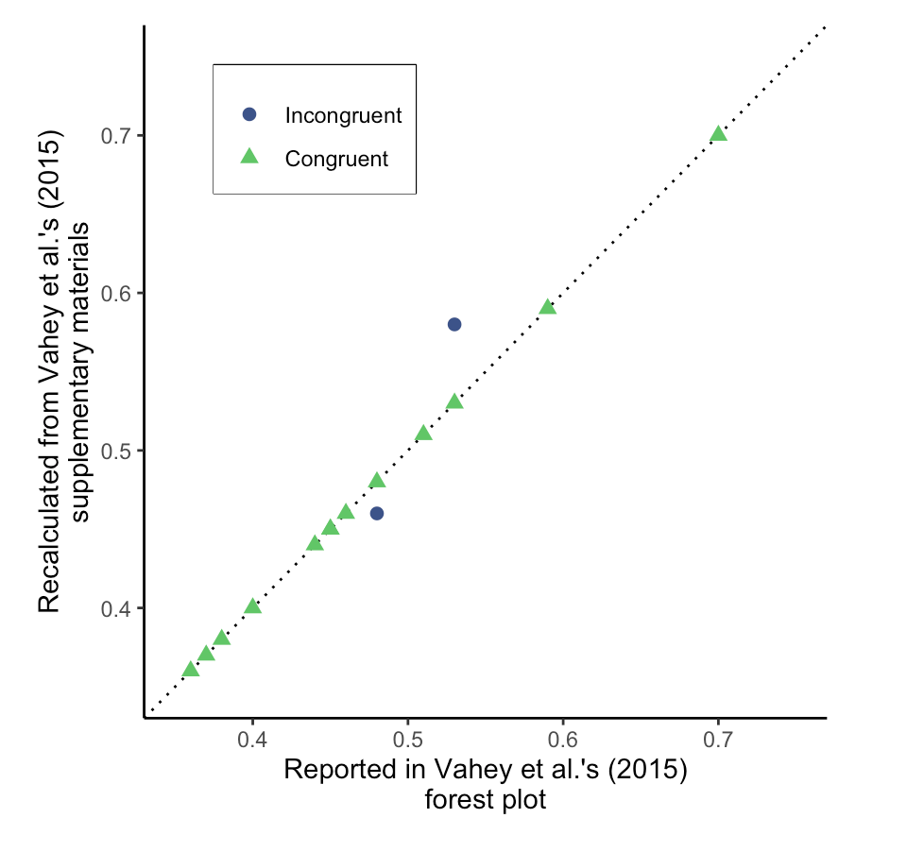

Figure XX. XXXX

## Individual effect sizes

Vahey et al.’s (2015) weighted-mean effect sizes in turn relied on the accuracy of the individual effect sizes that were extracted from original research articles (along with other statistics such as *N* and *df*) and, where applicable, the mathematical conversion between other effect sizes to Pearson’s *r*. I therefore attempted to computationally reproduce the individual effect sizes presented in Vahey et al.’s (2015) supplementary online materials. I make a distinction between two subsets of effect sizes and their reproducibility.

The first subset refers to effect sizes that could be reextracted and converted to Pearson’s *r*. In these cases, reproducibility refers to the numerical congruence between the effect sizes I obtain and those reported by Vahey et al. (2015). Wherever possible, the same effect size conversion method was employed as in the original meta-analysis, following the approaches listed in their supplementary materials. However, while these approaches were listed by name, specific formulae or software implementations were not provided. 29 (52%) effect sizes could be reextracted. When rounding all effect sizes to two decimal places, nearly half of the effect sizes reported by Vahey et al. (2015) could not be computationally reproduced (13 effect sizes, 45%). The magnitude of the differences between Vahey et al.’s effect sizes and mine were large in some cases (Δ*r*max = -.44). Where differences were observed, Vahey et al.’s (2015) effect sizes were generally skewed in favour of the IRAP’s validity (see Figure XX).

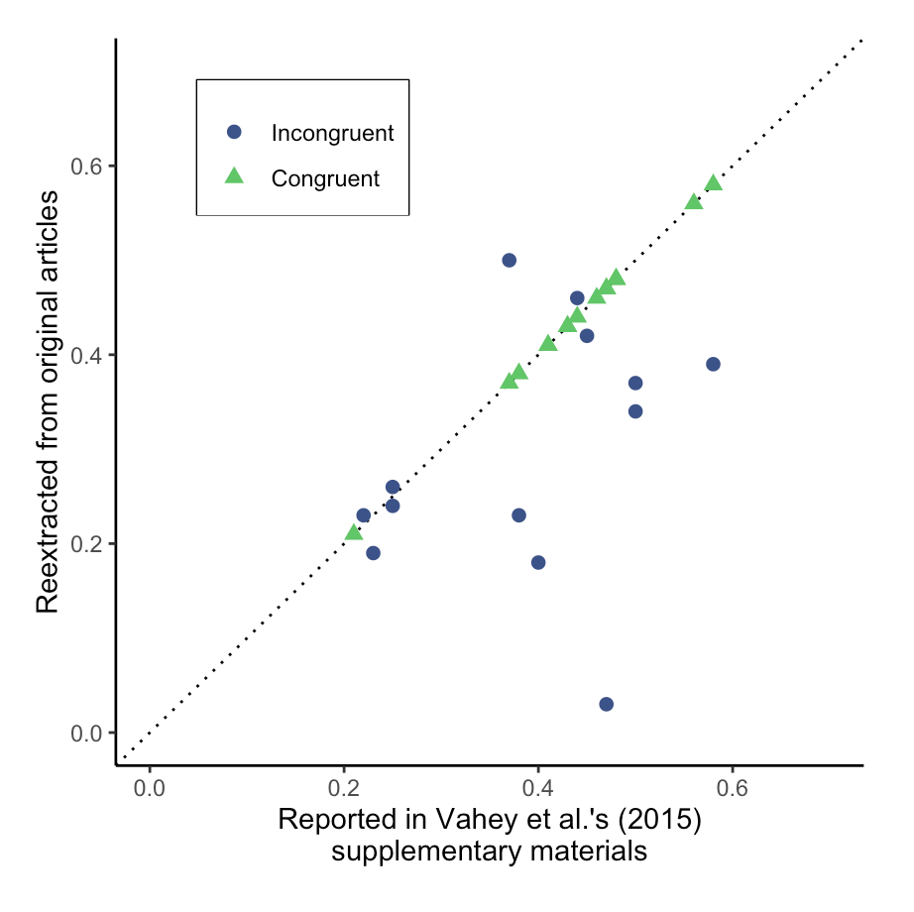

Figure XX. XX

The second subset of effect sizes refers to cases where I have a documented reason to believe that the effect size should not have been included in the meta-analysis for one or more of the following reasons. First, Vahey et al. (2015) appear to have treated $η_{p}^{2}$ as if it was equivalent to $η^{2}$, which it is not: (a) $η^{2}$ has a relatively simple mathematical transformation to Pearson’s *r*, which Vahey et al. (2015) appear to have incorrectly applied to $η_{p}^{2}$. However, $η_{p}^{2}$ cannot be converted to Pearson’s *r* as it is partial correlation. Additionally, $η_{p}^{2}$ has non-equivalent interpretation between different factorial designs (Lakens, 2013). As such, a number of $η_{p}^{2}$ effect sizes included by Vahey et al. (2015) were not reproduced.

Second, in some cases, effect sizes reported in Vahey et al.’s (2015) supplementary materials did not refer to effect sizes that were reported in the original article (e.g., Timko et al., 2010 Study 1: correlation between overall IRAP *D* score and DASS-total).

Third, in some cases, effect sizes referred to ANOVAs where mean IRAP *D* scores were used as the Dependent Variable (e.g., Kosnes et al., 2013, Parling et al., 2012; Hussey et al., 2012; Timko et al., 2010). Predicting mean IRAP effects from known groups tells us little about the IRAP’s validity, which would be appropriately assessed by through the IRAP’s ability to predict group membership. This analytic issue of swapping the IV and DV when attempting to provide evidence for a measure’s validity has been well documented elsewhere as a threat to research findings (Fried & Kievit, 2016).

Fourth, Vahey et al. (2015) included a large number of effect sizes that referred to tests of whether an IRAP effect had been demonstrated. That is, whether mean IRAP *D* scores were non-zero, or whether a reaction time differential was found between the consistent and inconsistent blocks. However, criterion validity can by definition only be established with reference to external variables. Quantifying the evidence for IRAP effects in isolation is at odds with Vahey et al.’s (2015) stated goal of assessing the IRAP’s clinically relevant criterion validity. As such, a number of effect sizes were not reproduced for this reason.

Finally, some effect sizes were not reported in sufficient detail in the original paper to allow for the calculation of an effect size. In such cases, I contacted the original authors, however in many cases I was not able to obtain additional data. These cases represent greater success by Vahey et al. (2015) in assembling results than I was able to achieve.

In total, only XX of XX effect sizes included in Vahey et al.’s (2015) supplementary materials were found to be computationally reproducible. Where reextracted values were found to differ, these differences were generally in the IRAP’s favour in Vahey et al. (2015, see Figure XX).

## Omitted effect sizes

XXX

Vahey et al.’s extractions were incorrect, but also his choices for what to include or not were also highly questionable.

* No mention of how many effect sizes were considered or rejected.
* Questionable omissions and blinding. Examples.
* Significance from zero effects
* IRAP as the DV
* Retrospective *a priori* predictions
* Inclusion of effects that do not meet the inclusion criterion of clinical relevance.

Vahey et al. extracted 56 effect sizes from 15 articles, but provided no information about the number of effects that were not included or details of these excluded effects. I re-extracted all effect sizes reported in these 15 articles, resulting in 334 effect sizes. Some additional effect sizes were found that were non-independent with the extracted ones (e.g., follow-up *t* tests after ANOVA, correlations with the overall IRAP score when its component trial types were also correlated, or correlations with a scale’s sum score when its subscale sum scores were also available). Two independent raters then rated each effect (both the IRAP domain and the criterion) for clinical relevance using Vahey’s definition. No exclusions were made on the basis of ‘retrospective a priori predictions’ on the basis that I strongly disagree that this is a meaningful classification effects in terms of its experimental replicability or its measurement reliability or validity. If either rater rated the effect as clinically relevant it was included in the meta-analysis. Agreement was found in 90% of cases (Cohen’s Kappa = 0.88, *p* < .0001).

## New meta-analysis

The majority of the step in Vahey et al.’s (2015) meta-analysis were not found to be computationally reproducible (i.e., meta-analysis results, calculation of weighted-mean effect sizes, or extraction and conversion of individual effect sizes). Where steps were found to be computationally reproducible, they were found to be poorly justified (e.g., power analyses). In some cases, one could argue that differences between the results reported by Vahey et al. (2015) and those reported here are small (e.g., meta-analytic effect size estimate). However, no individual step can be viewed in isolation. For example, the large differences in individual effect sizes had an as-yet unknown impact on the meta-analytic effect size estimate. In order to assess the compound impact of the reproducibility at each step on Vahey et al.’s (2015) final results and conclusions, a new meta-analysis was conducted, followed by new power analyses using the meta effect size.

Recent results from simulation studies suggests that the weighted-mean approach method employed by Vahey et al. (2015) to deal with non-independence of effect sizes estimates provides poor statistical power, and that the alternative approach of employing a multi-level meta-analysis model should instead be employed (REF). I therefore elected to employ a multi-level random effect meta-analysis, with random intercepts for study, without weightings (i.e., the default recommended), and using the Restricted Maximum Liklihood estimator function

After excluding effects that were rated as not being clinically relevant or which were based on analyses that were determined a priori to be problematic, 144 effect sizes remained for inclusion in the meta-analysis. The same choice of multi-level meta-analysis model was again employed. Results demonstrated a meta effect size *r* = .20, 95% CI [.12, .29], 95% CR [-.04, .44], *p* = .000005. Evidence of heterogeneity was found, *Q*(df = 141) = 195.21, *p* = .0017, 𝜏2 < 0.00. Based on the non-overlap of their confidence intervals, this estimate is significantly smaller than the effect size reported in the original meta-analysis (i.e., *r* = .45, 95% CI [.40, .54]).

Given the large number of effect sizes being meta-analyzed, results are illustrated using a Caterpillar plot rather than a Forest plot (i.e., no article labels are included and effects are sorted by size; see Figure 2).

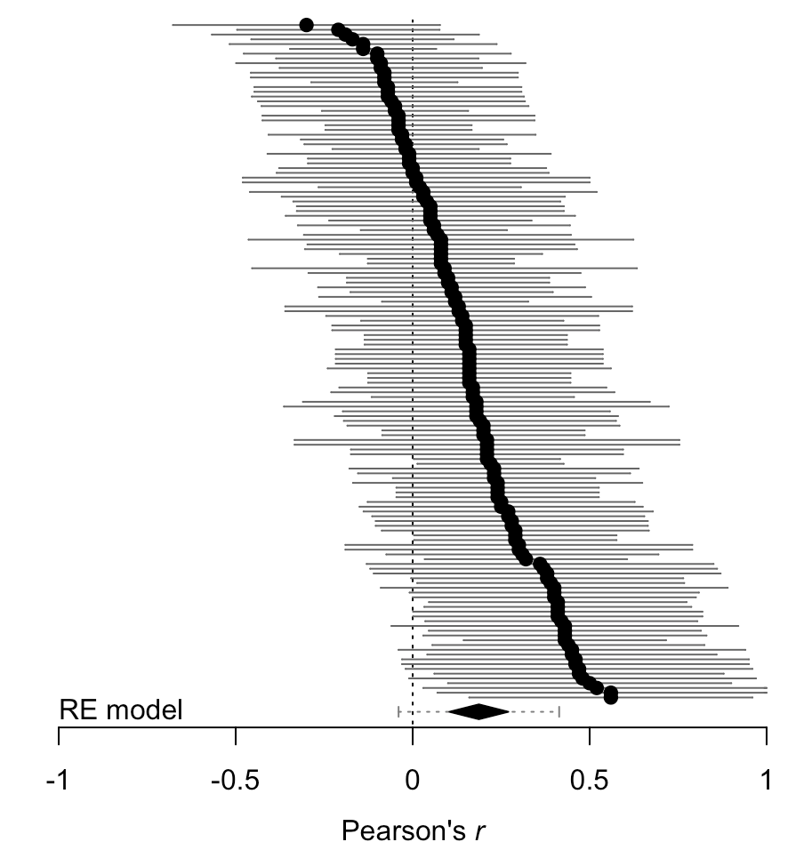

*Figure 2.* Caterpillar plot of the effect sizes and meta-analytic effect size estimate for the new meta-analysis.

As in the original meta-analysis, this estimate of effect size was used to calculate a power analysis for future sample size planning. To detect a zero order correlation with 80% power when alpha = .05 (two-sided), the minimum sample size was 194 participants (using the estimate) or 542 (using the lower bound of the estimate’s confidence interval). This represents a required sample size that is nearly fifteen times larger than recommended by Vahey et al. According to the systematic review (see Supplementary Materials), both of these estimates are more than ten times larger than the mean sample sizes employed in IRAP research to date.

## [old points]

The numeric results reported in the forest plot were also compared against estimations of the values displayed in the plot. No discrepancies were found in either the estimates or the confidence intervals.

While the degrees of freedom used were reported in supplementary materials, it was less clear how the samples sizes used for weightings and reported in the forest plot were obtained, given that the individual effect sizes that were converted to mean effect sizes were in many cases calculated from different sample sizes, yet the reported sample sizes were even numbers.

Assessment of bias

One or more authors of Vahey et al. (2105) was also an author of 12 of the 15 articles (80.0%) from which effect sizes were extracted, indicating that the authors of the original meta-analysis were familiar with the research they were meta-analysing.

## Summary of findings

The meta-analysis reported by Vahey et al. was found to have poor reproducibility on multiple fronts. Nearly half of the effect sizes included in the original meta-analysis did not match those reextracted from the original articles. In one third of cases, the effect sizes used in the original meta-analysis were biased upwards relative to the re-extractions done here. Data processing was found to not be reproducible, with 13% of cases demonstrating disagreement between the weighted average effect sizes reported in the forest plot and those recalculated from the effect sizes reported in the supplementary materials. The specifics of the meta-analytic strategy were not completely described in the text. Unfortunately, requests made to the first author of the original meta-analysis for the original data and code were refused. When the data reported in the original meta-analysis’s forest plot were refitted using a best estimation of the original meta-analytic strategy, results differed from those reported in the original (albeit, by a small amount). More worryingly, when all effect sizes were reextracted from the original articles a large number of questionable inclusions and inclusions were highlighted. When all effect sizes were included that a) met Vahey et al.’s inclusion criterion of being clinically relevant and b) were not derived from types of analyses that were defined a priori as producing invalid or misleading results or conclusions, the meta effect size estimate reduced greatly (original *r* = .45, 95% CI [.40, .54], new: *r* = 0.13, 95% CI [0.03, 0.23]). Power analyses calculations for future research using this updated effect size estimate suggest minimum sample sizes of more than 460 participants; an estimate that is 16 times larger than recommended by Vahey et al. and 10 times larger than the mean sample sizes employed in IRAP research to date.

At first glance, these sample sizes seem unfeasible, especially given many researchers experience of conducting IRAP research and obtaining significant results. However, results are not incompatible with this: IRAP papers frequently include a large number of statistical tests and comparisons and a very high ratio of tests to sample size. As such, the false positive rate is inevitably inflated. Future research should attempt to estimate the false positive rate in IRAP research, possibly via simulation studies (e.g., due to analytic degrees of freedom and multiple testing).

Improving the reproducibility of future meta-analyses

Results have implications for both the IRAP specifically (e.g., the interpretation of previously published findings and use in future studies), and also meta-analysis more generally. potential pitfalls involved in producing reproducible meta-analyses and interpreting the reproducibility of existing meta-analyses more generally.

Provide all data, including a codebook, and data regarding the excluded effect sizes. Provide all code and scripts for data processing and analyses. No written description of the analytic strategy will provide the same precision as the code used to implement them (along with session info information that includes the versions of software used along with details of the operating system and hardware used). Supplementary materials should not only be hosted on the journal’s website but also on reliable archival services (e.g., OSF, Zenodo, etc.). Organizing and publicly archiving such data ahead of time removes avoids many issues likely to be encountered in the future. For example, loss or misplacement of data and materials over time or unwillingness to search for them (all of which were encountered here when attempting to obtain data and materials from the authors of the original meta-analysis).

Explicate more details in text. For example, the weighting strategy was unclear in Vahey’s meta-analysis.

Conclusion

XXX

# References

Please enter references in the APA style and include a DOI where available.

Barnes-Holmes, D., Barnes-Holmes, Y., Stewart, I., & Boles, S. (2010). A sketch of the Implicit Relational Assessment Procedure (IRAP) and the Relational Elaboration and Coherence (REC) model. *The Psychological Record*, *60*, 527–542.

Corneille, O., & Hütter, M. (2020). Implicit? What Do You Mean? A Comprehensive Review of the Delusive Implicitness Construct in Attitude Research. *Personality and Social Psychology Review*, 1088868320911325. https://doi.org/10.1177/1088868320911325

De Houwer, J., & Moors, A. (2010). Implicit measures: Similarities and differences. In *Handbook of implicit social cognition: Measurement, theory, and applications* (pp. 176–193). Guildford Press.

Fried, E. I., & Kievit, R. A. (2016). The volumes of subcortical regions in depressed and healthy individuals are strikingly similar: A reinterpretation of the results by Schmaal et al. *Molecular Psychiatry*, *21*(6), 724–725. https://doi.org/10.1038/mp.2015.199

Golijani-Moghaddam, N., Hart, A., & Dawson, D. L. (2013). The Implicit Relational Assessment Procedure: Emerging reliability and validity data. *Journal of Contextual Behavioral Science*, *2*(3–4), 105–119. https://doi.org/10.1016/j.jcbs.2013.05.002

Greenwald, A. G., & Lai, C. K. (2020). Implicit Social Cognition. *Annual Review of Psychology*, *71*(1), 419–445. https://doi.org/10.1146/annurev-psych-010419-050837

Greenwald, A. G., McGhee, D. E., & Schwartz, J. L. (1998). Measuring individual differences in implicit cognition: The Implicit Association Test. *Journal of Personality and Social Psychology*, *74*(6), 1464–1480. https://doi.org/10.1037/0022-3514.74.6.1464

Heo, M., Kim, N., & Faith, M. S. (2015). Statistical power as a function of Cronbach alpha of instrument questionnaire items. *BMC Medical Research Methodology*, *15*. https://doi.org/10.1186/s12874-015-0070-6

Hussey, I., & Drake, C. E. (2020). The Implicit Relational Assessment Procedure demonstrates poor internal consistency and test-retest reliability: A meta-analysis. *Preprint*. https://doi.org/10.31234/osf.io/ge3k7

Lakens, D. (2013). Calculating and reporting effect sizes to facilitate cumulative science: A practical primer for t-tests and ANOVAs. *Frontiers in Psychology*, *4*. https://doi.org/10.3389/fpsyg.2013.00863

Lakens, D., Page-Gould, E., van Assen, M. A. L. M., Spellman, B., Schönbrodt, F. D., Hasselman, F., Corker, K. S., Grange, J., Sharples, A., Cavender, C., Augusteijn, H., Augusteijn, H., Gerger, H., Locher, C., Miller, I. D., Anvari, F., & Scheel, A. M. (2017). *Examining the Reproducibility of Meta-Analyses in Psychology: A Preliminary Report* [Preprint]. BITSS. https://doi.org/10.31222/osf.io/xfbjf

Maassen, E., Assen, M. A. L. M. van, Nuijten, M. B., Olsson-Collentine, A., & Wicherts, J. M. (2020). Reproducibility of individual effect sizes in meta-analyses in psychology. *PLOS ONE*, *15*(5), e0233107. https://doi.org/10.1371/journal.pone.0233107

Parsons, S. (2018). *Visualising two approaches to explore reliability-power relationships*. https://doi.org/10.31234/osf.io/qh5mf

Roefs, A., Huijding, J., Smulders, F. T. Y., MacLeod, C. M., de Jong, P. J., Wiers, R. W., & Jansen, A. T. M. (2011). Implicit measures of association in psychopathology research. *Psychological Bulletin*, *137*(1), 149–193. https://doi.org/10.1037/a0021729

Vahey, N. A., Nicholson, E., & Barnes-Holmes, D. (2015). A meta-analysis of criterion effects for the Implicit Relational Assessment Procedure (IRAP) in the clinical domain. *Journal of Behavior Therapy and Experimental Psychiatry*, *48*, 59–65. https://doi.org/10.1016/j.jbtep.2015.01.004

# Other information required for submission, not for review

Contribution Statement

Please list all contributions towards this manuscript, including their roles and affiliations at the time of data collection.

Ian Hussey was solely responsible for all contributions to this manuscript. I was affiliated with Ghent University, Belgium, when I began this project. I am now affiliated with Ruhr University Bochum, Germany.

Acknowledgements

Many thanks to Jamie Cummins for feedback on earlier versions of this manuscript.

Conflict of Interest

I acknowledge that one of the authors of the original article being verified (Prof Dermot Barnes-Holmes) was my PhD supervisor (2010-2015). I have not actively collaborated with Prof Barnes-Holmes since 2015. Articles lead by third parties of which we were both co-authors were published up to 2018. The author declares no other conflict of interest associated with the publication of this manuscript.

Funding statement

IH was supported by Ghent University grant 01P05517 (awarded in 2017) and the META-REP Priority Program of the German Research Foundation (#464488178) (awarded in 2021).

# Stage 1 Checklist

Include a separate page, confirming explicit agreement of the following:

1. All necessary support (e.g., funding, facilities, etc.) and approvals (e.g. ethics) are in place for the proposed research
2. The cover letter includes an anticipated timeline for completing the work if the initial submission is accepted
3. The authors agree to share their raw data, materials and code as appropriate.
4. In the event of the submission achieving Stage 1 in-principle acceptance, authors confirm that they agree to the journal registering their approved protocol on their behalf on the Open Science Framework (OSF) using its dedicated Stage 1 VR registration mechanism https://osf.io/rr/ (please see the Verification Report author guidelines for further details). The journal will provide the corresponding author with the URL to this registered protocol in the Stage 1 editorial acceptance letter, and authors must later include this URL in the Stage 2 manuscript. Note that the journal will register the protocol ONLY once the Stage 1 manuscript is in-principle accepted, and not if it is rejected or withdrawn by authors prior to being awarded in-principle acceptance.

For each author who currently has an account on the OSF (https://osf.io/), please provide their name and the URL of their OSF home page. E.g. “Thomas Rhys Evans, osf.io/ydmcr”. In the event of the Stage 1 protocol receiving in-principle acceptance, journal staff will include these authors as contributors to the OSF registration. It is not required that all authors have an OSF account, but only authors with an OSF account will be included by journal staff as contributors to the registered protocol on the OSF. At least ONE author must have an OSF account to ensure that the registered protocol is linked to at least one member of the authoring team. In the event of Stage 2 acceptance, authors without an OSF account will still be named as authors on the published article.

If the submission achieves Stage 1 in-principle acceptance, authors can instruct the journal to either make the registered Stage 1 manuscript immediately public on the OSF or instead register it under a private embargo for up to 4 years from the date of registration. If authors choose a private embargo, the embargo will be released and the registered protocol made public when any one of the following conditions are met: (a) submission of the Stage 2 manuscript; (b) withdrawal of the submission after in-principle acceptance and consequent triggering of a Withdrawn Registration (see Q5); or (c) natural expiry of the embargo period. Please choose the authors’ preferred method of registration following Stage 1 in-principle acceptance: Made public immediately OR Under private embargo. If choosing a private embargo please enter the duration of the embargo following in-principle acceptance. This can be specified either as a duration (e.g. “2 years”) or as a specific future date. The embargo period must be less then 4 years. Any entries that exceed this permissible maximum will be treated by the journal as “4 years”.

1. The authors confirm that if they withdraw their paper following Stage 1 in-principle acceptance then they agree to the journal (a) lifting any applicable private embargo on the registered Stage 1 protocol, thus making the protocol public on the OSF; and (b) publishing a short summary of the pre-registered study under the journal section Withdrawn Registrations, which will include the abstract of the Stage 1 submission, the URL of the registered Stage 1 protocol on the OSF, and a stated reason for the withdrawal.
2. Should Stage 1 in-principle acceptance be forthcoming, authors will be asked to provide the journal office with an estimated submission date for the completed Stage 2 manuscript. This deadline can be readily altered in consultation with the editors (e.g., in case of delays requiring additional time to complete the research). However, in the event that the authors (a) fail to submit the Stage 2 manuscript within 6 months of the mutually agreed deadline, while also (b) becoming non-responsive during this period to editorial enquiries, then the manuscript will be considered by the journal to be withdrawn, triggering publication of a Withdrawn Registration as outlined in Q5. Please confirm the authors’ agreement to these conditions.
3. The authors confirm that both of the following statements are true: (a) none of the authors of the Verification Report were authors or co-authors of the original work, and (b) none of the authors of the Verification Report are active collaborators of any of the authors of the original work (including holding shared grant funding in the previous three years or any other close connections).
4. The authors confirm that the cover letter makes clear whether the authors are submitting their Stage 1 manuscript prior to acquiring the data (and if so, a confirmation that all necessary permissions to acquire and reanalyse the data have been granted by the original authors/data custodian) OR instead whether they have already acquired the data and completed the (re)analyses but with the results redacted.

I, the single author, Ian Hussey (osf.io/3kzh8), confirm my agreement to all of the above points.